1. Level 3: Use hypermedia (HATEOAS)

For example:

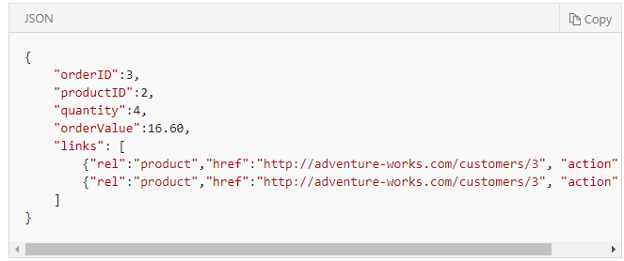

With response, possible URIs.

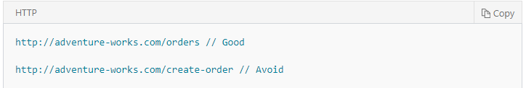

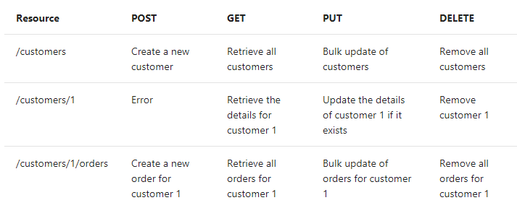 3. Filter and paginate data